iOS SQLite Storage Assignment (Add Contact)

Pooja Shah 010828311

Learning objective: Use SQLite to store contacts data.

1. **App Behavior**

Contact Page : Fig 1 shows the contact page with inputs such as name, email, phone, address, location.

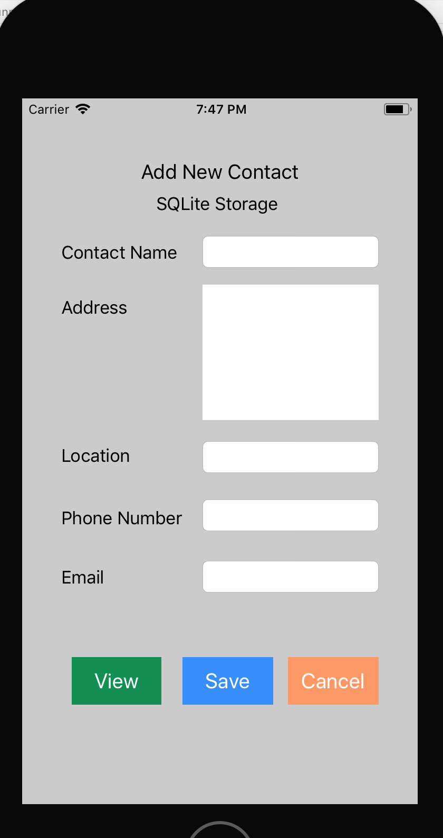

Fig 1. Contact page

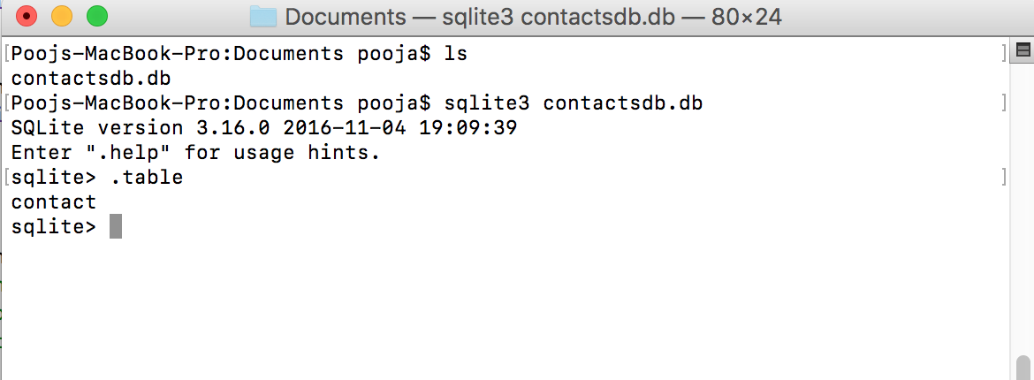

Fig 2. Contact table gets created but no data

Fig 2 shows the values of contactsdb.db database.

Add New Contact Page : Fig 3 shows the values that will be inserted after clicking on “Save” in the contactsdb.db database.

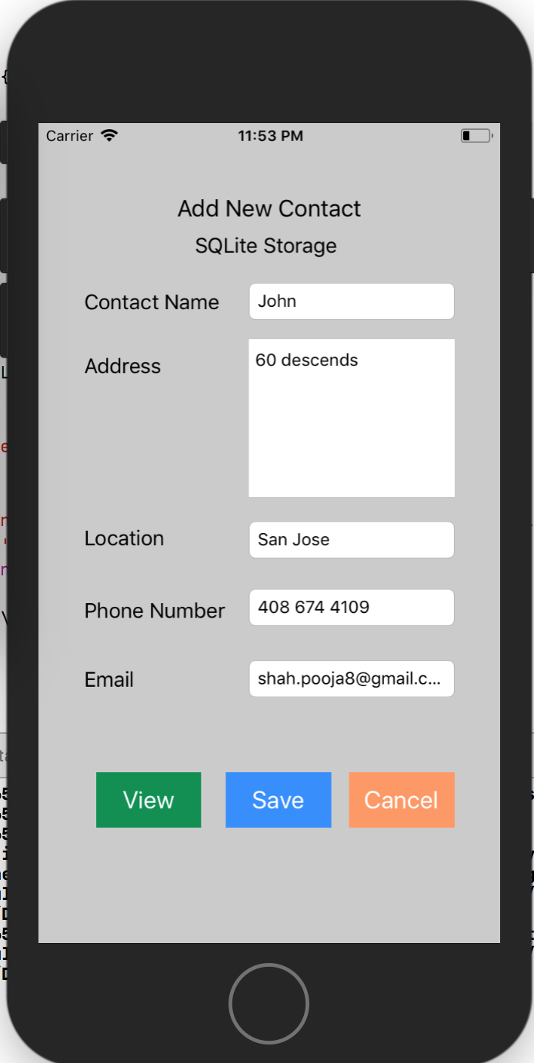

Fig 3. Add new Contact page

View Contacts Page :Fig 4 shows the values from contactsdb.db database after clicking on “View”.

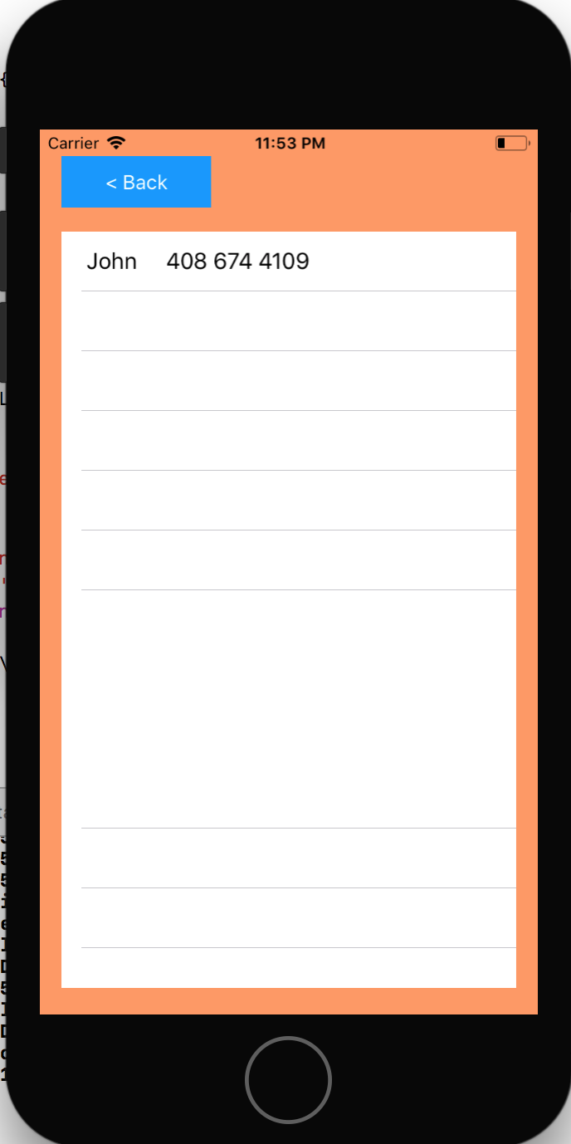

Fig 4. View Contact page

Fig 5 shows the contactsdb.db database and its table values in SQLite. John gets added.

SQLite 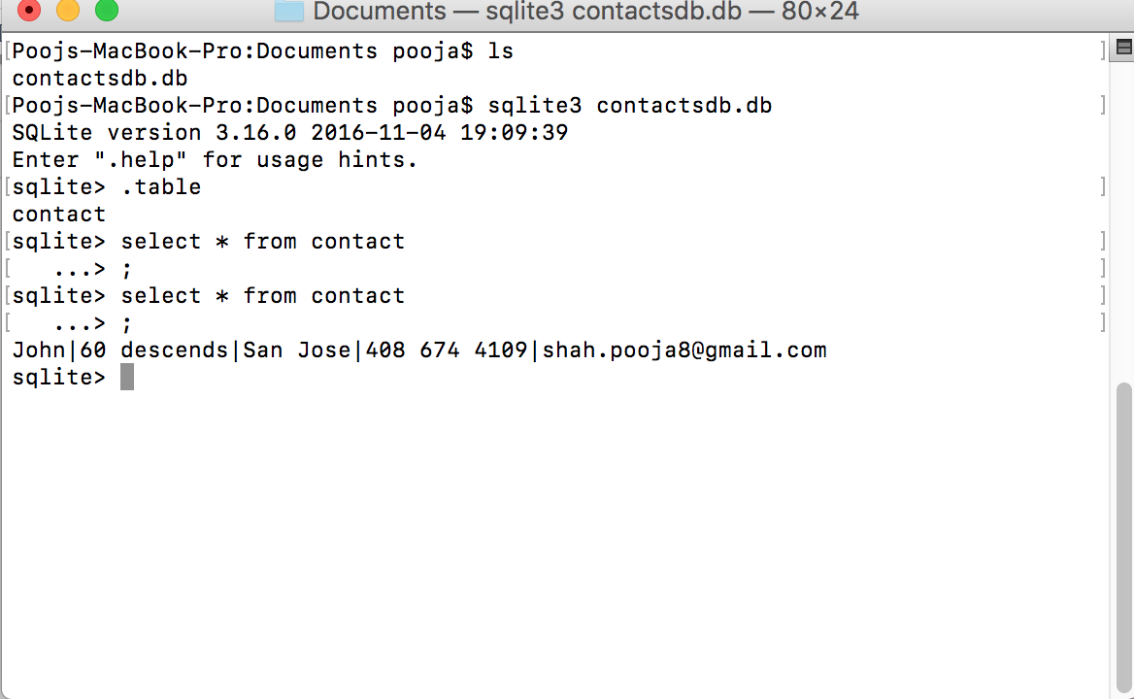

Fig 5. SQLite database and table values

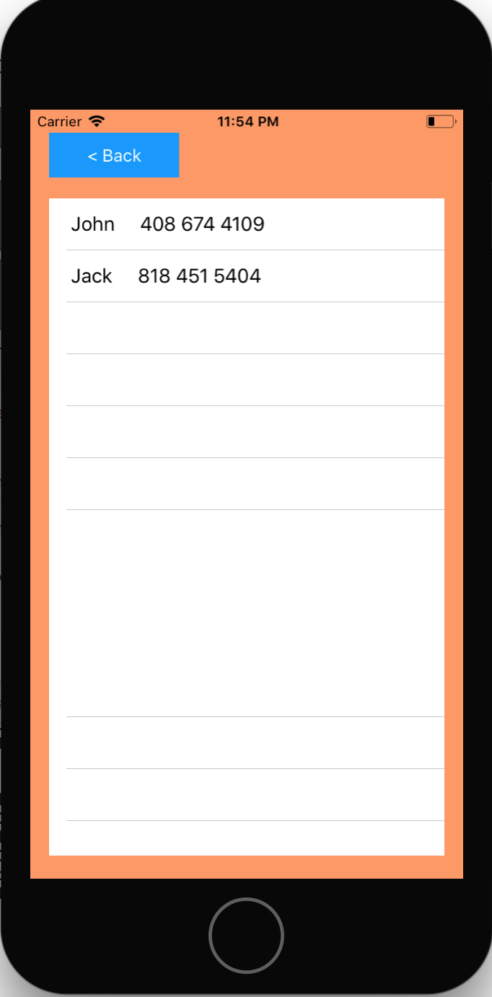

Fig 6. Adding One more entry

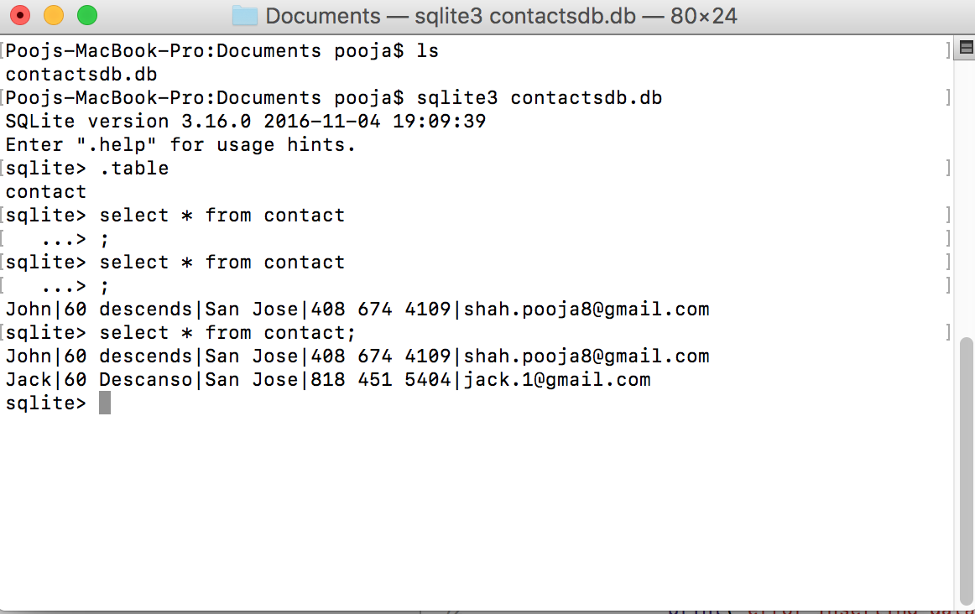

Fig 7. SQLite DB updated

1. **Technologies**

Libraries used :

1. SQLite3
2. UIKit
3. TableViewController

SQLite3 commands :

1. Create database
2. Insert into database
3. Create table
4. Select * from table